**DEPARTMENT OF**

**SCHOOL OF COMPUTING**

**College of Engineering and Technology**

**SRM Institute of Science and Technology**

MINI PROJECT REPORT

ODD Semester, 2023-2024

Lab code & Sub Name : 21CSS201T & Computer Organization and Architecture

Year & Semester : II & III

Project Title : **MICRO-PROCESSOR BASED DOOR OPENER**

Lab Supervisor **: Dr.Abijah Roseline S**

Team Members : 1. Harsh Bhayana (Reg.No: RA2211026010532)

2. Ankarboina Surabhi (Reg.No:RA2211026010527)

3. Anu Shree VS (Reg.No:RA2211026010566)

|  |  |  |
| --- | --- | --- |
| **Particulars** | **Max. Marks** | **Marks Obtained** |
| **Name:** |
| **Register No :** |
| Program and Execution | 20 |  |
| Demo verification &viva | 15 |  |
| Project Report | 05 |  |
| **Total** | **40** |  |

**Date :**

**Staff Name :**

**Signature :**



**COLLEGE OF ENGINEERING AND TECHNOLOGY**

**SRM INSTITUTE OF SCIENCE AND TECHNOLOGY**

**(Under Section 3 of UGC Act, 1956)**

S.R.M. NAGAR, KATTANKULATHUR – 603 203

**BONAFIDE CERTIFICATE**

Certified that Mini project report titled MICRO-PROCESSOR BASED DOOR OPENER

is the bonafide work of Reg. No RA2211026010527 , RA2211026010566 , RA2211026010532 Name ANU SHREE VS , HARSH BHAYANA , ANKARBOINA SURABHI who carried out the minor project under my supervision. Certified further, that to the best of my knowledge, the work reported herein does not form any other project report or dissertation on the basis of which a degree or award was conferred on an earlier occasion on this or any other candidate.

**SIGNATURE SIGNATURE**

**(GUIDE) HEAD OF THE DEPARTMENT**

**Dr. R Annie Uthra**

Professor and Head ,

Department of Computational Intelligence,

SRM Institute of Science and Technology

**TABLE OF CONTENTS**

|  |  |  |
| --- | --- | --- |
| **S No.** | **Title** | **Page No.** |
| 1 | Problem Statement |  |
| 2 | Methodology / Procedure/ Algorithm |  |
| 3 | Flowchart |  |
| 4 | Coding (C/Python) |  |
| 5 | Front-end code (HTML, CSS, Javascript) [Optional] |  |
| 6 | Modules of the proposed work |  |
| 7 | Results/Screenshots |  |
| 8 | Conclusion |  |
| 9 | References |  |

**MICRO-PROCESSOR BASED DOOR OPENER**

**OBJECTIVE:**

The objective of the project titled "Microprocessor-Based Door Opener using 8051 Microprocessor" is to design and implement a secure and efficient system for remotely controlling the opening and closing of a door. This system leverages the 8051 microcontroller to provide convenient and reliable access control, enhancing security and accessibility in various applications, such as homes, offices, and industrial settings

**ABSTRACT:**

The "Microprocessor-Based Door Opener using 8051 Microprocessor" project is designed to address the need for an intelligent, secure, and user-friendly door control system. The project aims to utilize the capabilities of the 8051 microprocessor to create a robust and versatile solution for door access control

**INTRODUCTION:**

* In recent times, the demand for automatic door openers has seen significant growth. This project presents an innovative solution for automated access using a microprocessor-based control system.
* The primary objective of this project is to provide a convenient and efficient method for opening and closing doors without the need for manual intervention.
* Our system eliminates the need for human gate monitoring and manual operation. It uses remote control technology for effortless access.
* Unlike traditional gates, our automatic gate system offers intelligent features such as obstacle detection and dynamic control.

**SOFTWARE REQUIREMENTS:**

8051 MICROPROCESSOR BASED KEIL COMPILER

**CONCEPTS/WORKING PRINCIPLE**

A microprocessor-based door opener using the 8051 microcontroller is a common embedded systems project. This system can be used to control and automate the opening and closing of doors using software. Here's an overview of the concepts and working principles involved:

Software Components:

* Microcontroller Programming: The 8051 microcontroller is programmed using a high-level language such as C or assembly. The software handles input from sensors, processes commands from the user interface, and controls the motor/actuator.
* Control Logic: The control logic is the software algorithm that decides when to open or close the door. This logic could be based on user input (e.g., entering a PIN or presenting an RFID card), sensor input (e.g., detecting an obstruction in the door's path), or a predetermined schedule

**ADVANTAGES OF SYSTEM:**

1. **Improved Security:**
   * Enhanced security is a paramount benefit of the microprocessor-based door opener system. By using advanced authentication methods like RFID cards, PIN entry, or biometric recognition, the system ensures that only authorized individuals gain access.
   * Access logs and audit trails can be maintained, allowing administrators to track who accessed the door and when. This feature is particularly valuable in offices and industrial settings where security is a top concern.
   * In residential applications, the system can offer peace of mind, knowing that your home is secure from unauthorized entry.
2. **Convenience:**
   * The convenience factor cannot be overstated. Users have the flexibility to open doors remotely, whether they are at home, the office, or even when away on vacation. This is achieved through various methods, such as smartphone apps or web interfaces.
   * User-friendly interfaces make it easy for individuals of all ages to operate the system. In residential settings, this means that children or elderly family members can use the system with ease.
3. **Safety:**
   * Safety is a paramount concern, especially in environments with heavy foot traffic or where there's a risk of accidents. The system's obstacle detection features are crucial in industrial settings where heavy machinery operates, preventing collisions between the door and objects or people.
   * At home, these safety features can protect children or pets from getting trapped in closing doors, enhancing the overall safety of the household.
4. **Automation:**
   * Automation is key to reducing the need for manual operation and gate monitoring. In office settings, employees don't need to manually unlock and open doors for visitors. This not only streamlines access but also frees up valuable human resources for more critical tasks.
   * In industrial environments, automation is the backbone of efficiency. The system can be integrated with other automation processes, allowing for seamless entry and exit of goods and personnel.

**APPLICATIONS :**

* **Home Automation:**

**In residential settings, the microprocessor-based door opener system is a fundamental component of modern home automation. It provides a sophisticated layer of security and convenience.**

**Examples include:**

1. **Smart Homes: Integration with smart home systems, allowing homeowners to control doors, lights, and other devices with a single interface.**
2. **Package Delivery: Facilitating secure package deliveries by enabling remote access for delivery personnel.**
3. **Guest Access: Providing temporary access codes or virtual keys for guests and service providers, ensuring secure yet convenient entry.**

* **Office Access Control: • The system's applications in office environments are diverse and revolve around access control and security. Key examples are:**

1. **Employee Access: Ensuring that only authorized employees can enter specific areas within the office premises.**
2. **Visitor Management: Streamlining the process of granting access to visitors, contractors, and clients.**
3. **Time and Attendance: Integrating access control with time and attendance systems for accurate tracking of employee work hours.**

* **Industrial Settings: • Industrial environments benefit from enhanced security and automation. Specific use cases include:**

1. **Factory Automation: Integrating the system with production processes for secure and efficient entry and exit of materials and personnel.**
2. **Warehouse Management: Facilitating smooth operations in warehouses, where doors often serve as access points for inventory and logistics.**
3. **Safety Compliance: Ensuring that safety regulations are met by incorporating obstacle detection and safety protocols.**

**In addition to the aforementioned advantages and applications, the microprocessor-based door opener system is part of the broader trend of the Internet of Things (IoT) and smart building technologies. It is poised for further developments, including increased integration with other IoT devices, enhanced energy efficiency, and the potential for predictive maintenance to prevent system failures.**

* **Moreover, as technology continues to advance, the system can become more affordable and accessible, potentially reaching a wider range of users and applications. The increasing importance of smart home technologies and the demand for seamless connectivity across different systems further enhance the potential of microprocessor-based door opener systems in the coming years.**
* **Lastly, it is crucial to note that as these systems continue to evolve, security remains a paramount concernFor. instance Integration, with as existing self security protocol-sd andriv ongoinging development cars of become new security more measures pre will bevalent, advanced parking essential systems to maintain the effectiveness and adapt couldability of le microverageprocessor the capabilities of microprocessor--based doorbased door op openerener systems in systems various to settings manage. and secure vehicle access to designated parking areas. This could further augment the potential of this technology and its integration into broader smart systems and applications.**
* **As such, the microprocessor-based door opener system has a promising future in various settings, driven by the continued evolution of technology and the growing need for enhanced security, convenience, and efficiency in different contexts.It is also worth noting that these systems are constantly evolving to adapt to changing market needs and advancements in technology. For example, advancements in artificial intelligence (AI) and machine learning (ML) have the potential to enhance security features, while advancements in cybersecurity can ensure data protection and privacy. These ongoing advancements in technology ensure that microprocessor-based door opener systems will continue to evolve and provide unparalleled convenience, security, and connectivity to users across various sectors.To ensure long-term reliability**

**APPROACH/METHODOLOGY/PROGRAMS:**

**The code uses a 8051 microcontroller with some input pins connected to a sensor (likely a gate status sensor) and output pins connected to control the gate's motor or mechanism. The code's purpose is to open and close the gate based on the input from the sensor. Here is a breakdown of the methodology and approach used in this code:**

**1. Software Setup:**

**- The program assumes that there are some input and output pins configured in the 8051 microcontroller. Input pins (p10) are connected to the gate status sensor, and output pins (p11, p12, p13) control the gate motor.**

**2. Gate Status Variable:**

**- The `gateStatus` variable is used to keep track of the gate's status, whether it's open or closed. It is initialized to 0, assuming the gate is initially closed.**

**3. Main Loop:**

**- The `while (1)` loop is the main program loop, which runs indefinitely.**

**4. Delay Functions:**

**- Two delay functions, `delay1` and `delay2`, are defined to create time delays. These functions are used for controlling the gate's movement and adding a delay between gate operations.**

**5. Gate Control Logic:**

**- The code checks the status of the `p10` input pin, which represents the gate status sensor. It appears that a logic HIGH (1) indicates the gate is closed, and a logic LOW (0) indicates the gate is open.**

**- The code uses conditional statements to control the gate motor (p11, p12, and p13) based on the gate's current status (`gateStatus`).**

**- If the gate sensor (`p10`) detects that the gate is closed (p10 == 1) and the `gateStatus` is 0 (indicating that the gate is closed), the code opens the gate by setting appropriate output pins, adds a delay, and updates the `gateStatus` to 1 (indicating that the gate is now open).**

**- If the gate sensor (`p10`) detects that the gate is open (p10 == 0) and the `gateStatus` is 1 (indicating that the gate is open), the code closes the gate by setting appropriate output pins, adds a delay, and updates the `gateStatus` to 0. It also turns off the motor by setting `p11` to 0.**

**- If the gate sensor (`p10`) detects that the gate is open (p10 == 1) and the `gateStatus` is 1, the code appears to be stopping the gate movement by setting all motor control pins to 0.**

**6. Delay Timing:**

**- The `delay1` and `delay2` functions create delays using nested loops. These delays are used to control the speed of the gate's movement.**

**It's important to note that this code provides basic gate control functionality and relies on the state of a single sensor (`p10`) to determine the gate's status. The `delay1` and `delay2` functions control the timing of the gate's operations.**

**Code:**

**#include <reg51.h>**

**sbit p10 = P1 ^ 0;**

**sbit p11 = P1 ^ 1;**

**sbit p12 = P1 ^ 2;**

**sbit p13 = P1 ^ 3;**

**int gateStatus = 0;**

**void delay1();**

**void delay2();**

**void main(void) {**

**while (1) {**

**delay1();**

**if (p10 == 1 && gateStatus == 0) {**

**p11 = 1;**

**p12 = 0;**

**p13 = 1;**

**delay2();**

**gateStatus = 1;**

**} else if (p10 == 0 && gateStatus == 1) {**

**p11 = 1;**

**p12 = 1;**

**p13 = 0;**

**delay2();**

**gateStatus = 0;**

**p11 = 0;**

**} else if (p10 == 1 && gateStatus == 1) {**

**p11 = 0;**

**p12 = 0;**

**p13 = 0;**

**}**

**}**

**}**

**void delay1() {**

**int i, j;**

**for (i = 0; i < 10; i++) {**

**for (j = 0; j < 10000; j++) {}**

**}**

**}**

**void delay2() {**

**int i, j, f = 0;**

**for (i = 0; i < 10; i++) {**

**for (j = 0; j < 30000; j++) {}**

**}**

**}**

As a monitoring and control system, the microcontroller was used to read data values from input devices and communicate with the outside world. In the microcontroller 8051 Pins, 1 to 8 are the PORT 1 Pins. PORT 1 Pins consists of 8 – bit bidirectional Input / Output Port. there are other pins that handle different things like pin 9 is used for reset operations.

**FLOWCHART:**

**OUTPUT:**

**Before changing ports status:**

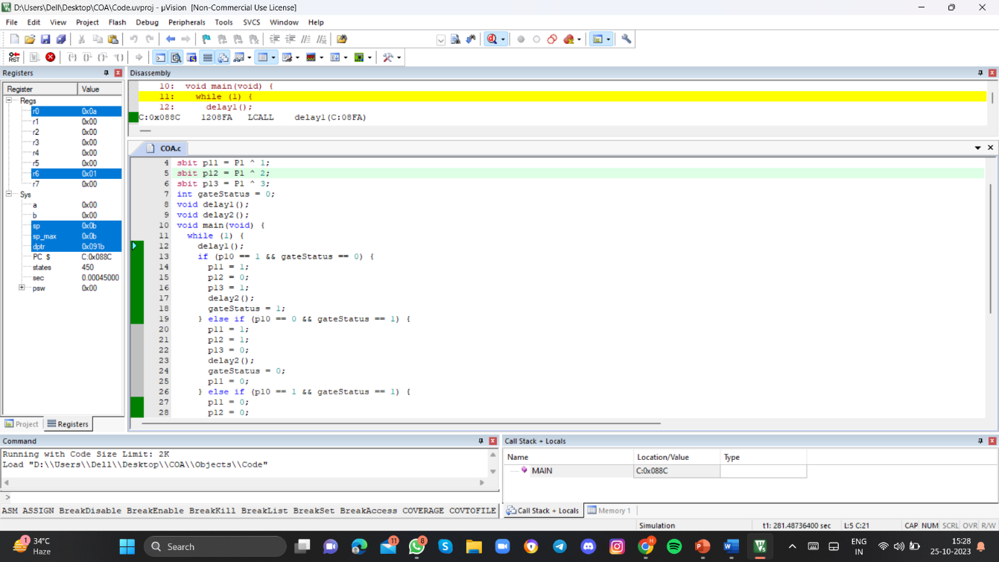

**After changing ports(port 1) status:**

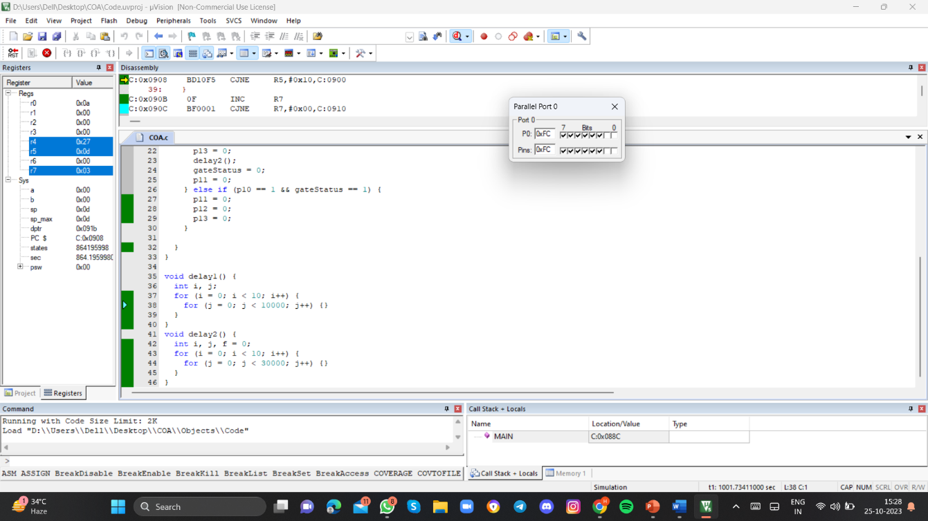

**CONCLUSIONS:**

The provided code is written in C for an 8051 microcontroller. It controls a gate mechanism based on the state of input p10 and maintains a gate status variable to track whether the gate is open or closed. The code employs simple delay functions to control the timing of operations.

**REFERENCES:**

1. **<https://www.researchgate.net/publication/228631957_Design_of_a_Microprocessor_Based_Automatic_Gate>**
2. Private Door Openers. 2006. “Private Door Information”. Lombard, IL. <http://www.privatedoor.com>.
3. Microprocessor and Logic Design, Krutz, R.L. 198, John Wiley & Sons, Inc.: New York, NY.